TripMate – Carpooling Web Application

Project Report
1. Cover Page
Project Title : TripMate – Carpooling Web Application
Course : Environmental Values (EVS) Project
Submitted By : MALEPATTU KARTHIK
Roll Number : 25MEI10096
Department : INTEGRATED MTECH IN CYBER SECURITY
Submitted To : Pavithra R R mam
Institution : VIT BHOPAL UNIVERSITY
Academic Year : 2025–2026

2. Introduction
TripMate is a simple and user-friendly carpooling platform designed to reduce travel costs, traffic congestion, and carbon emissions. The application allows users to offer rides, find rides, and travel together, making transportation more economical and eco-friendly.
This project aims to demonstrate how technology can contribute to environmental sustainability and promote resource sharing.

3. Problem Statement

Many individuals travel alone in their personal vehicles, resulting in:
1.Wasted fuel
2.Higher travel costs
3.Increased carbon pollution
4.Traffic congestion
Difficulty for students and employees to find affordable travel options.There is a need for a simple platform where people can share rides safely and efficiently.

4. Functional Requirements

1. Add Ride
Driver can create a ride by providing name, source, destination, price, and available seats.

2. Search Ride
Users can search for available rides based on destination or route.

3. View All Rides
Shows a list of all posted rides.

4. Book a Seat
Reduces seat count by one when someone books.

5. Delete a Ride
Driver can remove a ride if needed.

6. Simple Console/Web Interface
User-friendly input and display.

5. Non-Functional Requirements

1. Usability – Must be easy for beginners to use.
2. Performance – Fast search and display of rides.
3. Reliability – Data should be stored and processed accurately.
4. Scalability – Should allow more features in the future.
5. Maintainability – Code must be simple and easy to update.
6. Security – Basic input validations and safe data handling.

6. System Architecture

A simple layered architecture:
User Layer – User interacts through console/web interface.
Application Layer – Business logic (add ride, search ride, book ride).
Data Layer – Rides stored in list/dictionary/database (based on implementation).

7. Design Diagrams

a. Use Case Diagram

Actors: User, Driver
Use Cases: Add Ride, Search Ride, View Rides, Book Ride
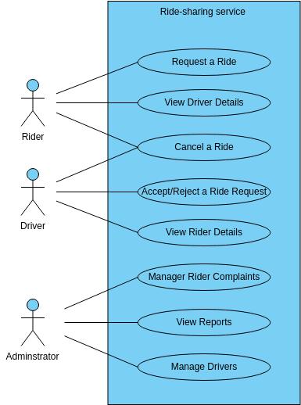

b. Workflow Diagram

1. Start →
2. Display Menu →
3. User selects action →
4. Perform action (Add/Search/View/Book) →
5. Show result →
6. Loop to menu →
7. Exit
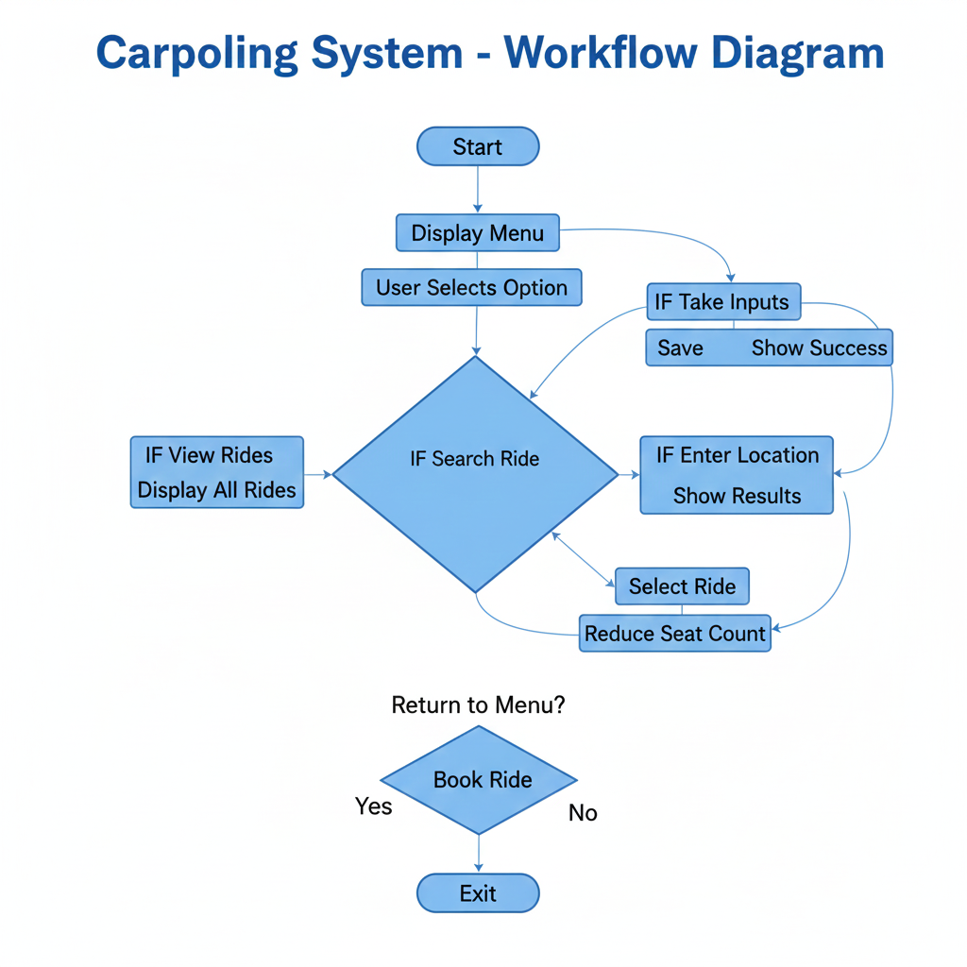

c. Sequence Diagram
User → Application → Data Storage

Example (Add Ride):
User inputs details → System validates → System stores ride → Confirmation sent.

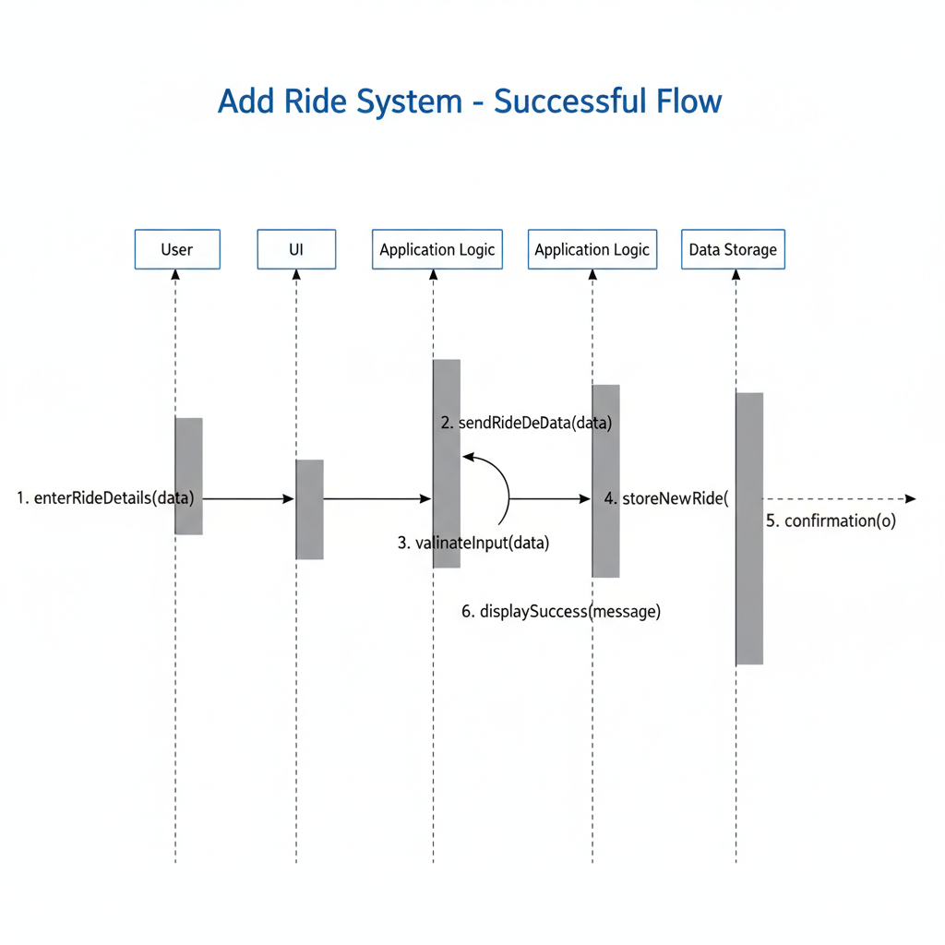

d. Class Diagram

Classes: Ride, RideManager
Components: UI Component, Logic Component, Storage Component

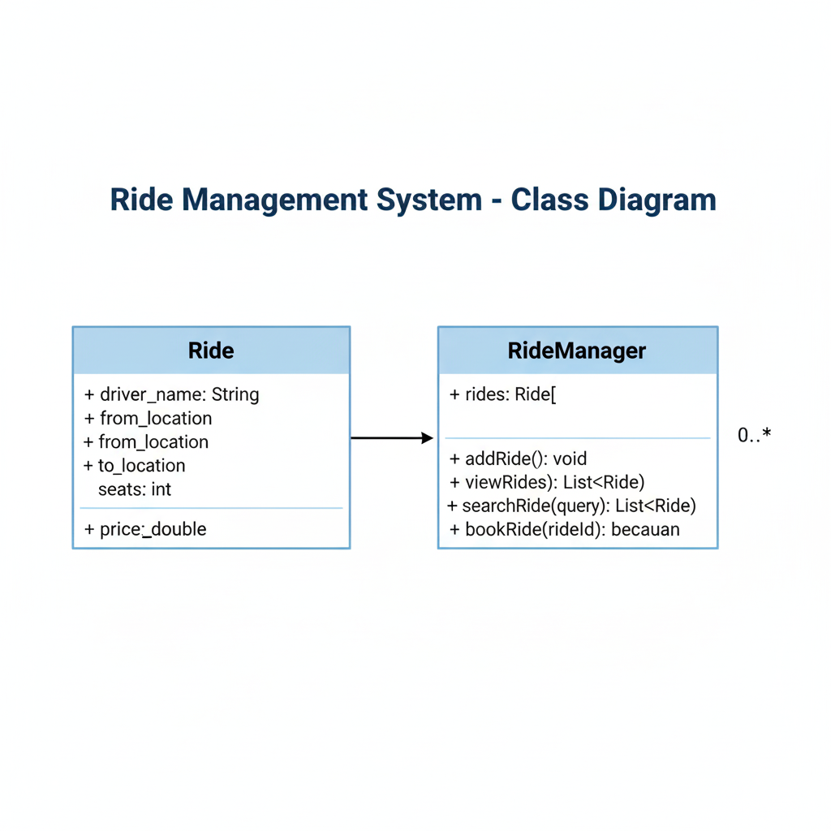

e. ER Diagram

Entities:
Ride (ride_id, driver_name, from, to, seats, price)
Relationships: 1 Ride → Many Users (optional)
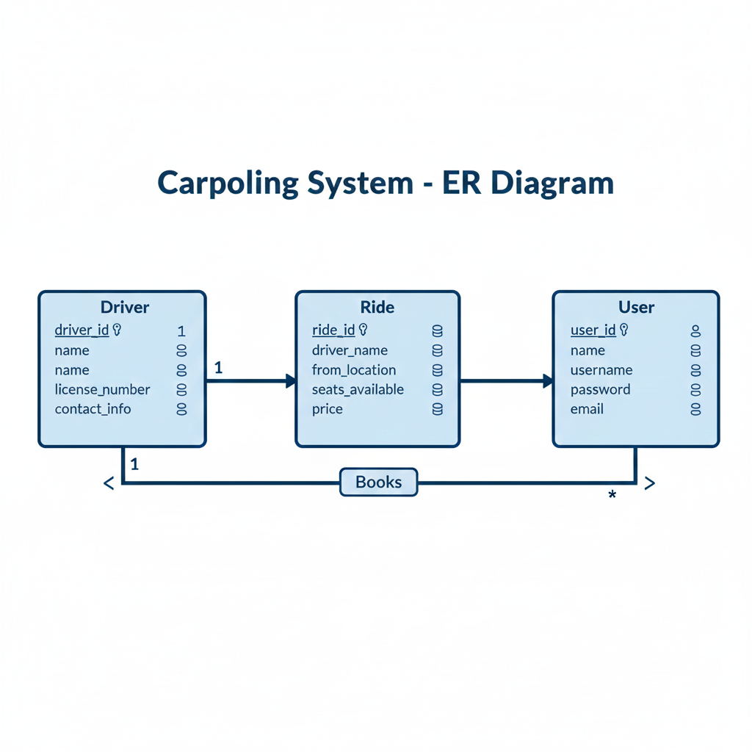

8. Design Decisions & Rationale

Python chosen for simplicity and readability.
List/Dictionary used for storage to keep the program lightweight.
Modular functions (add_ride, view_rides, search_ride) used for clarity.
Simple text-based UI chosen to make the project easy to run on any system.

9. Implementation Details

The program is implemented in Python using basic data structures. Rides are stored in a list, where each ride is represented as a dictionary. Functions handle adding, searching, viewing, and booking rides. Input validation ensures proper data entry. Program loops until the user exits.

10. Screenshots / Results
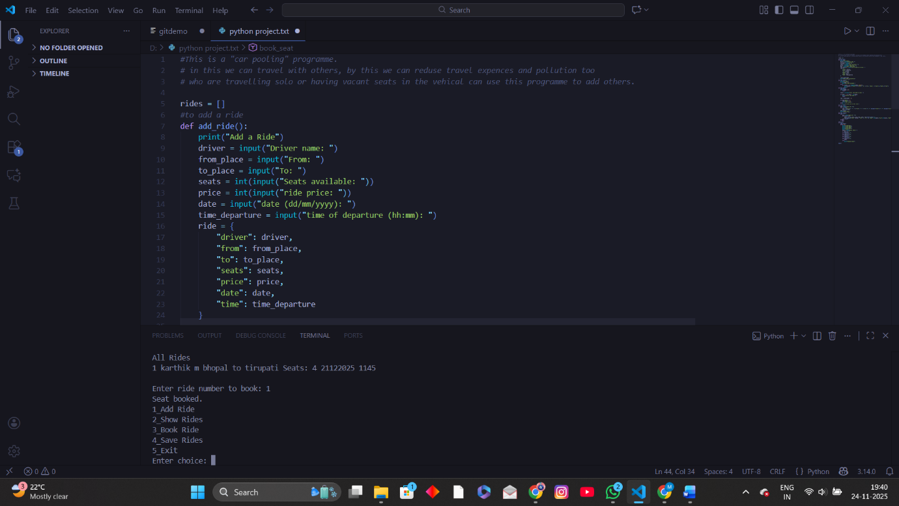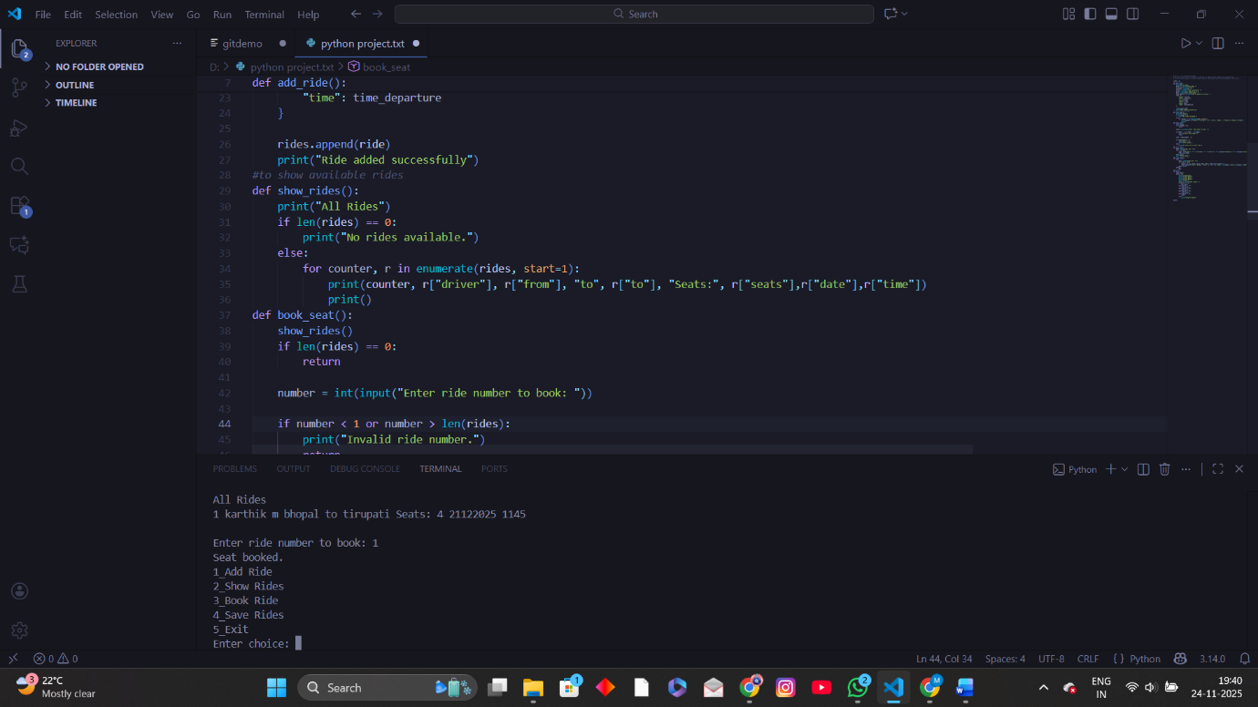
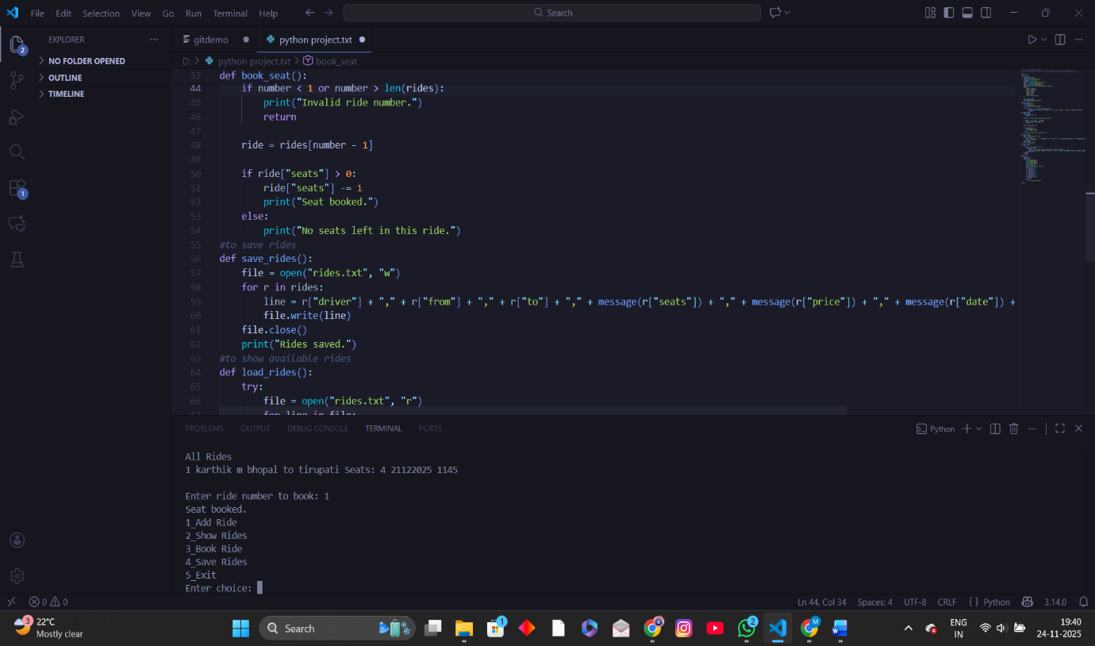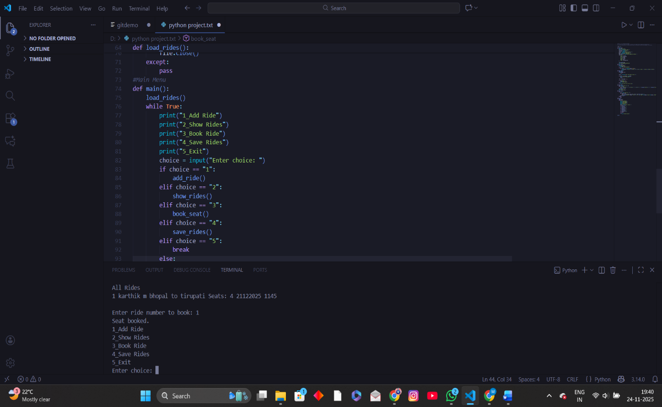
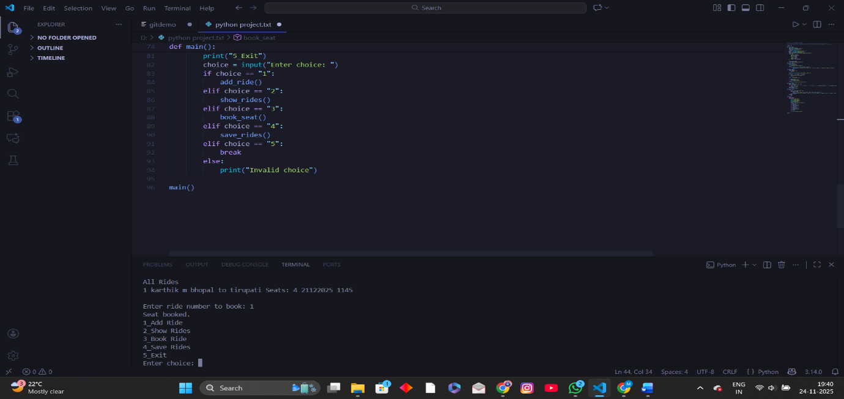

11. Testing Approach

1. Unit Testing
Testing individual functions like add_ride(), search_ride().

2. Input Testing
Wrong inputs, blank inputs, invalid numbers.

3. Functional Testing
Checking the correctness of results after each action.

4. User Testing
Tested by classmates to ensure ease-of-use.

12. Challenges Faced

Designing the structure of ride storage.
Handling input errors.
Ensuring the search feature works correctly.
Creating meaningful diagrams and layout.

13. Learnings & Key Takeaways

1.Learned how carpooling helps reduce pollution.
2.Improved understanding of Python functions and data structures.
3.Learned project documentation and diagram creation.
4.Understood how real-world apps manage data and user interaction.
5.Enhanced problem-solving and debugging skills.

14. Future Enhancements

->Add login and authentication.
->Add online database for real-time updates.
->Live location tracking.
->Rating system for drivers and riders.
->Mobile app version.
->Payment integration.
->Pollution reduction meter.
15. References

Python Documentation
Vityarthi essentials in python course
EVS Sustainability course modules
Carpooling concept research papers
Class materials and faculty guidance

